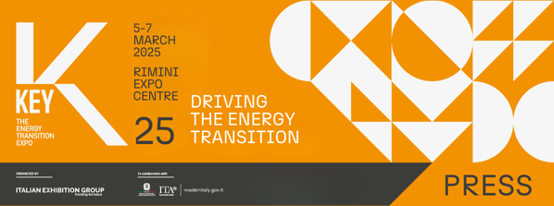

press release
(English translation)

KEY - THE ENERGY TRANSITION EXPO:
ENERGY EFFICIENCY AND THE ENERGY OF THE FUTURE TO WIN THE DECARBONISATION CHALLENGE

- The fundamental schedule of events programmed from 5th to 7th March 2025 at Italian Exhibition Group's Rimini Expo Centre has been published
- From hydrogen to AI, renewables, electric mobility, urban transition and industrial and built environment efficiency: all the KEY25 topics

Rimini (Italy), 10th December 2024 – Studies, research and observatories, as well as meetings, conferences and debates to reflect on the present and future of energy transition and efficiency with the aim of increasingly accelerating the road towards decarbonisation. KEY – The Energy Transition Expo’s Technical-Scientific Committee, chaired by Professor Gianni Silvestrini and made up of Institutions, Industrial Trade Associations, Technical-Scientific Associations, Organisations and Foundations, is at work to define the conference schedule for the next edition of the event, organised by IEG (Italian Exhibition Group) and a reference point in Europe, Africa and the Mediterranean basin. The appointment will be from 5th to 7th March 2025 at Rimini Expo Centre.

KEY25'S FUNDAMENTAL CONFERENCE PROGRAMME
ForumTech: on the first day of the show, Wednesday, 5th March 2025, Italia Solare Association's ForumTech will be making its annual appearance at KEY. This event brings together industry experts, researchers, academics and professionals to discuss the latest new entries and future trends in the field of photovoltaics and to explore the latest technologies, innovative materials and advanced solutions for improving the efficiency and integration of photovoltaics into existing infrastructures.

Smart and sustainable cities with increasingly efficient industries and buildings: from industry to sports, the redevelopment of real estate, the role of Public Administration, sustainable construction and the efficiency of the built environment in the light of the “Case Green” Energy Performance of Buildings Directive (EPBD). At KEY, energy efficiency will be a core topic, offering energy managers, EGEs, utilities, ESCOs, verification and monitoring platform providers and every other stakeholder involved, the chance to exchange best-practices and case studies with a complete overview of the state of the art, obstacles, opportunities and actions needed to achieve decarbonisation targets. Moreover, the conferences scheduled at KEY will focus on analysing the transformation of cities towards greater resilience to change by exploring the role of cutting-edge technologies with a focus on solutions applicable to future urban contexts.

Artificial Intelligence in the energy sector: for the first time, KEY will be inquiring into the possible applications of AI in the energy sector through meetings and workshops aimed at illustrating the options currently available and the results obtained by projects already underway, as well as promoting reflections on the opportunities, risks, ethical aspects and environmental impact that adopting this technology implies. During the three-day event, FIRE will present the results of a survey conducted among technology providers and users.

Energy transition between opportunities, regulations and authorisations: energy transition not only increases a country's energy autonomy and security, it also contributes to creating new jobs and technological growth. The current uncertain geopolitical scenario risks slowing down the process and affecting rising energy costs, which must be controlled. The conferences scheduled at KEY will involve all the players concerned with the aim of identifying possible solutions capable of making the transition sustainable with specific focus on the regulatory framework, the criticalities hindering business investments, and the role of the Regions, such as Sardinia, through the presentation of a study conducted by Milan Polytechnic.

Ports and off-shore wind energy: wind energy growth is supported by the development of veritable hubs in Italian ports, leading players in the Mediterranean. Starting from the Ministry of the Environment and Energy Security's commitment to initiating an important stage in industrial development in Southern Italy by creating a logistic platform at the service of the growth of marine renewables, events scheduled at KEY25 will address the topic of wind energy, focusing on the technologies that have enabled the sector’s significant progress, on energy storage and on production and maintenance optimisation due to the implementation of advanced control systems that integrate AI, augmented reality, and drones. KEY25 will also see the debut of Su.port - Sustainable Ports for Energy Transition, an exhibition on port dock electrification and the development of offshore wind power, especially floating.

New perspectives for hydrogen: Hydrogen Valleys, regional green hydrogen supply chains already underway or getting started, the sustainability of renewable fuels of non-organic origin, such as e-fuels and hydrogen, and the integration of hydrogen and new sustainable energy carriers at airports. Hydrogen will be one of KEY’s main protagonists both within the conference programme and in the new HYPE - Hydrogen Power Expo supported by Hydrogen & Fuel Cells exhibition area, set up by Italian Exhibition Group and Hannover Fairs International GmbH (HFI), the Italian branch of Deutsche Messe AG.

The electric transition of mobility: existing technologies and adoption trends, public and private infrastructure along the road and motorway network, focus on hard-to-abate sectors such as medium and long-distance heavy road transport, maritime and air transport: the KEY25 programme will address the broad topic of mobility transition by approaching it from several different viewpoints with panels and conferences attended by institutions, companies and industry associations. KEY will also be one of the stops on the Observatory on the Transformations of the Automotive Ecosystem’s roadshow.

Photovoltaics and agriculture, a winning synergy: despite being a crucial and innovative solution for producing energy from renewable sources, agrovoltaics is still coming up against numerous environmental and landscape barriers that are hindering its implementation. At KEY, the aim is to provide an overview of the solutions currently available and explore best practices for developing sustainable and landscape-integrated agri-voltaic projects by delving into policies, regulations and strategies that can facilitate the adoption of this technology.

Renewable Energy Communities, a virtuous model: in view of the birth of the first Italian Renewable Energy Communities, RSE and Legambiente will be presenting their respective mapping with the aim of analysing the spread of this model and understanding the prevailing organisational models, the most widely used technologies and the role of the institutions and organisations involved. Legambiente will award prizes to the best RECs in terms of quality and solidarity project implementation and will explain the best practices of the BeComE project that it has generated with Kyoto Club and AzzeroCO2.

Energy storage to align supply and demand: storage systems, especially of long duration, are key to accelerating the transition towards renewable energy in a cost-effective, reliable and sustainable way, ensuring security of supply and timely response even during moments of peak electricity demand. However, some challenges remain, such as regulatory uncertainties and high upfront costs. These are issues that KEY25 will address through scheduled events, including the presentation of the 4th edition of the ANIE and RSE White Paper.

Africa, a key player in the green future: with its huge natural resources and renewable energy endowments, Africa has the potential to become a key player in the global green future. And yet, despite the progress made in recent decades, the continent is still far from achieving the goals of the 2030 Agenda. It will have to face fundamental energy challenges with electrification, digitisation and the development of strategic professional skills playing a central role. This will be discussed again this year at KEY in the traditional appointment with RES4Africa Foundation.

The KEY25 conference schedule is constantly being updated and can be consulted on the event’s website at the following link: www.key-expo.com/eventi.

Moreover, scheduled to take place at Rimini’s Palacongressi Conference Centre, Tuesday 4th March 2025, the eve of KEY, will see the second edition of KEY CHOICE - Unlock the future of PPA, the B2B event of KEY - The Energy Transition Expo dedicated to Power Purchase Agreements, organised by IEG (Italian Exhibition Group) in cooperation with Elemens.

ABOUT KEY 2025
Event: International trade show; Organisation: Italian Exhibition Group S.p.A.; Frequency: annual; Edition: 3rd; Dates: 5-7 March 2025; mail keyenergy@iegexpo.it; Website: http://www.key-expo.com; Facebook: https://www.facebook.com/keyexpo/; Instagram: https://www.instagram.com/key_expo/; LinkedIn: https://www.linkedin.com/company/keyenergy/

PRESS CONTACT KEY - ITALIAN EXHIBITION GROUP
head of media & corporate communication: Elisabetta Vitali; press office manager: Marco Forcellini, Pier Francesco Bellini; international press office coordinator: Silvia Giorgi; press office coordinator: Luca Paganin; press office specialists: Nicoletta Evangelisti, Mirko Malgieri; media@iegexpo.it

MEDIA AGENCY: Smartitaly Communications
Sara Scatena, s.scatena@smartitaly.it, mob. +39 338 7836985; Arianna Geli, a.geli@smartitaly.it, mob. +39 347 0917903

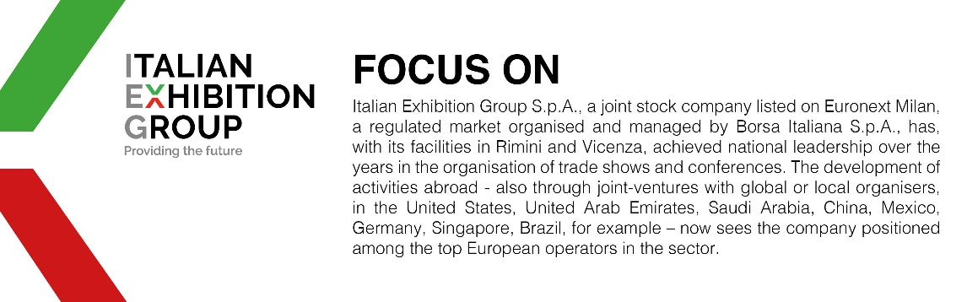

This press release contains forecast elements and estimates that reflect the management’s current opinions (“forward-looking statements”), particularly regarding future management performance, realization of investments, cash flow trends and the evolution of the financial structure. For their very nature, forward-looking statements have a component of risk and uncertainty, as they depend on the occurrence of future events. The effective results may differ (even significantly) from those announced, due to numerous factors, including, only by way of example: food service market and tourist flow trends in Italy, gold and jewellery market trends, green economy market trends; the evolution of raw material prices; general macroeconomic conditions; geopolitical factors and evolutions in the legislative framework. Moreover, the information contained in this release does not claim to be complete, and has not been verified by independent third parties. Forecasts, estimates and objectives contained herein are based on the information available to the Company as at the date of this release.

